**Devops Project**

**Using AWS EC2, Git, Jenkins and Docker**

**AWS EC2:** Create an EC2 Instance type (t3: medium) for handling the Jenkins and Docker workload.

**GIT:** Git is a version control system is contains the code of the application.

**Jenkins (CI/CD Automation):** Using commands we are going install in AWS EC2.

Jenkins is mainly using to building the pipelines for automating the manual workload.

Commands link:

<https://www.jenkins.io/doc/tutorials/tutorial-for-installing-jenkins-on-AWS/>

**Docker (Containerization):** Docker is mainly used to build the image of the developed code.

Installation commands link:

<https://docs.aws.amazon.com/serverless-application-model/latest/developerguide/install-docker.html>

Pipeline Code:

pipeline {

agent any

stages {

stage('Cloneing the code ') {

steps {

sh 'git clone git code url'

}

}

stage('Container creating'){

steps{

sh '''

cd simple-devops-website

docker build -t devops_demo1:v1 .

'''

}

}

stage('Deploying Container'){

steps{

sh 'docker run -d -p 80:Port devops_demo1:v1 '

}

}

}

}

Port = ex: 3000

**Workflow:**

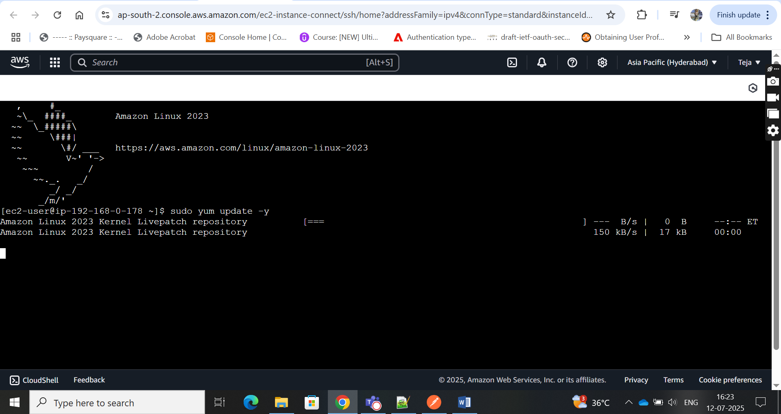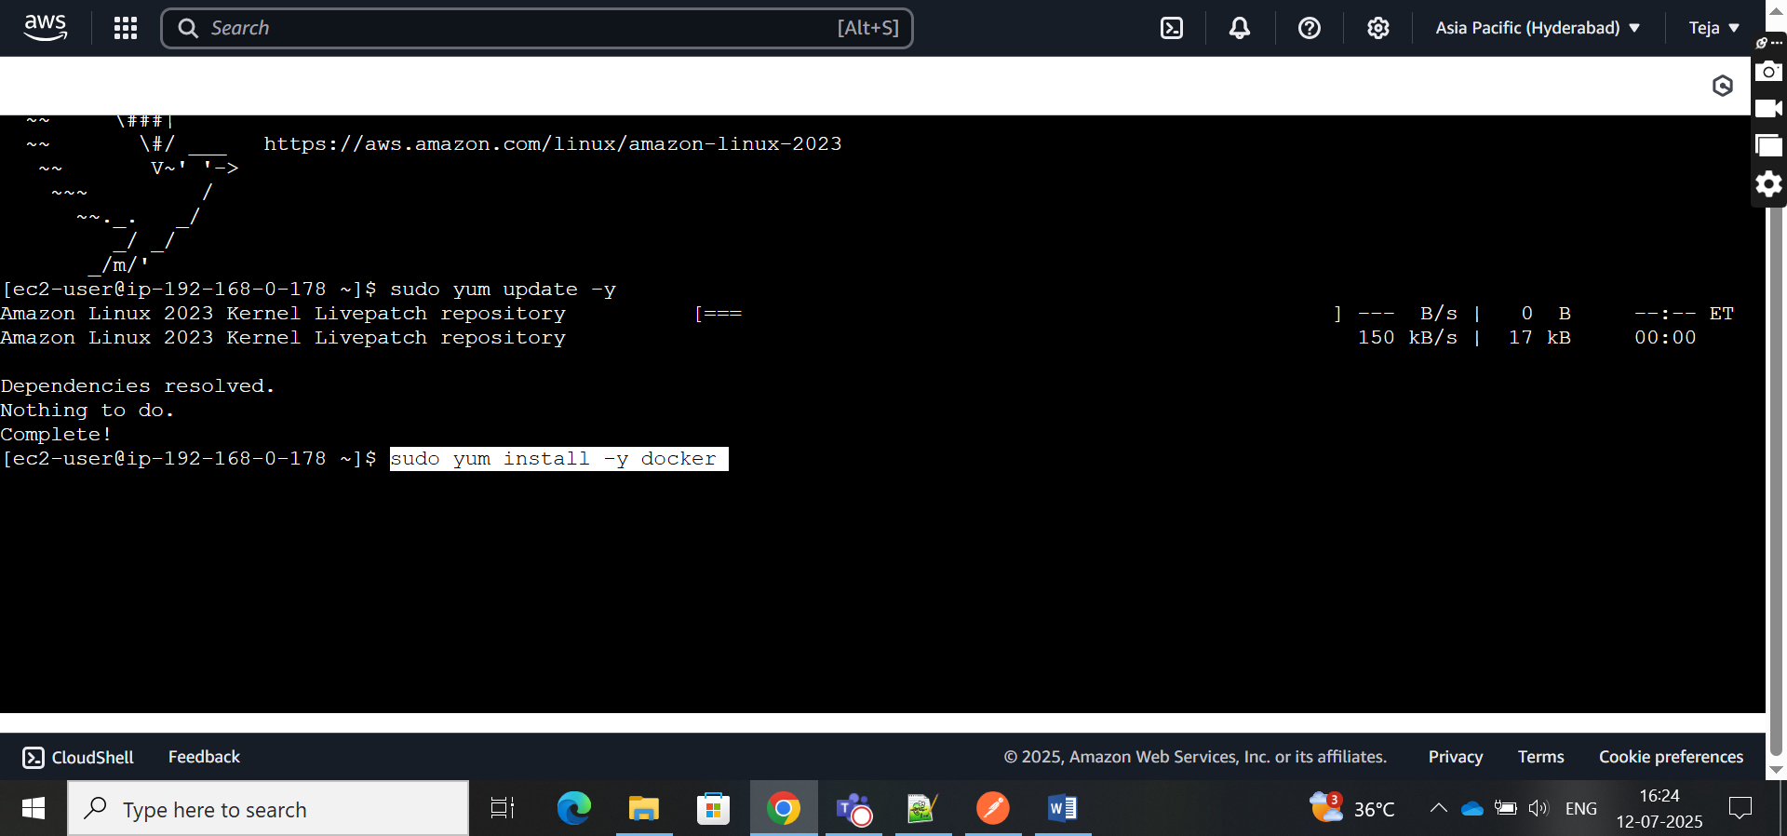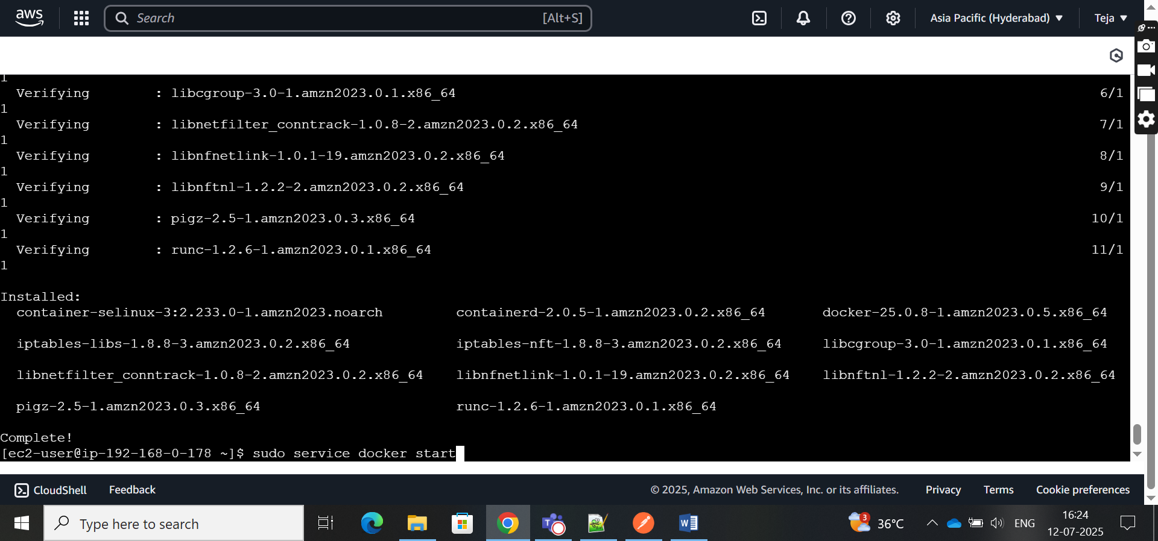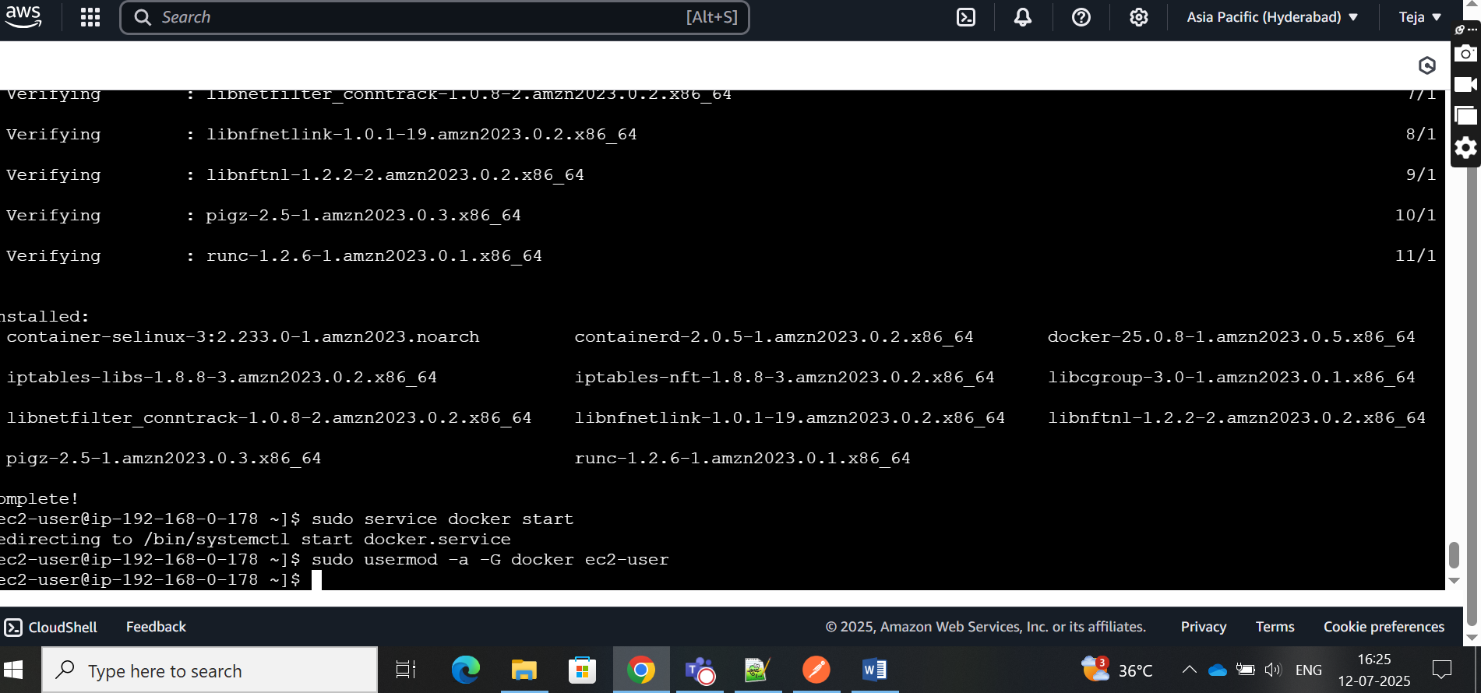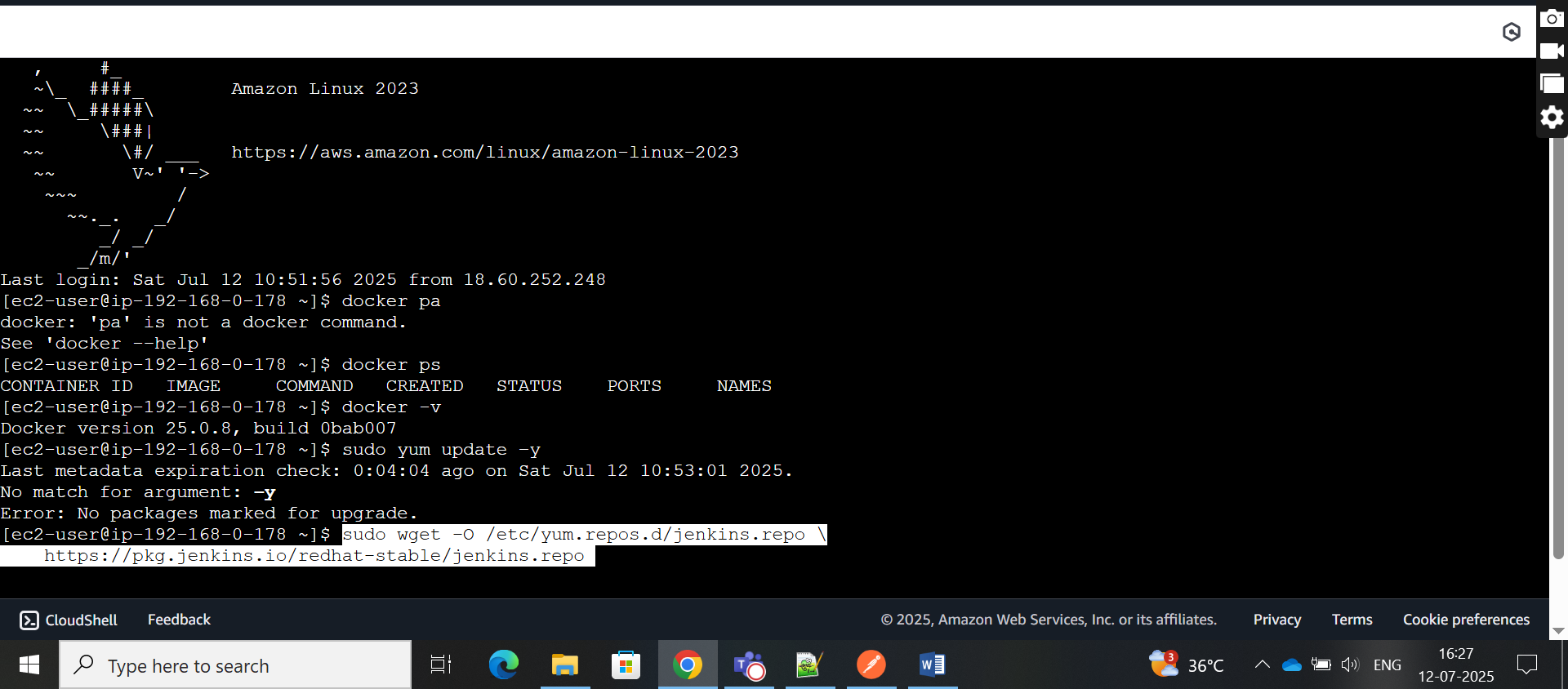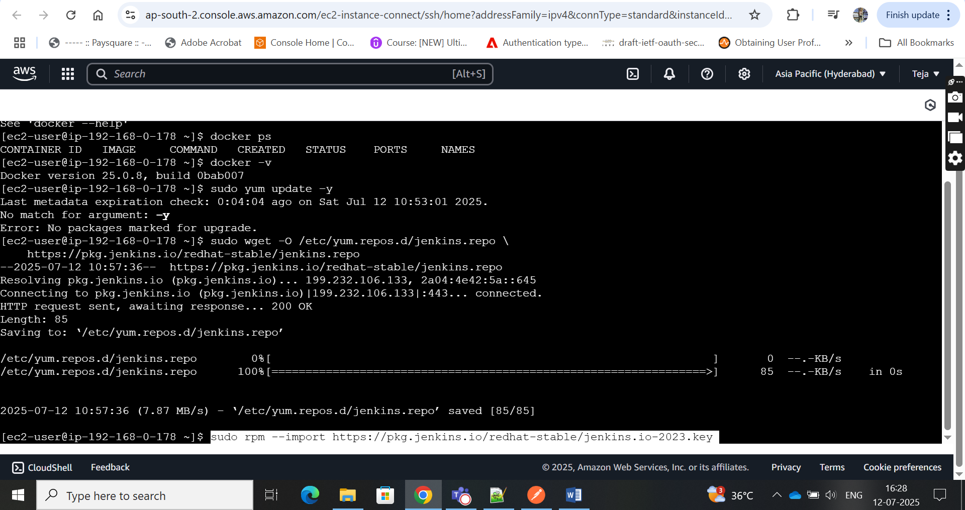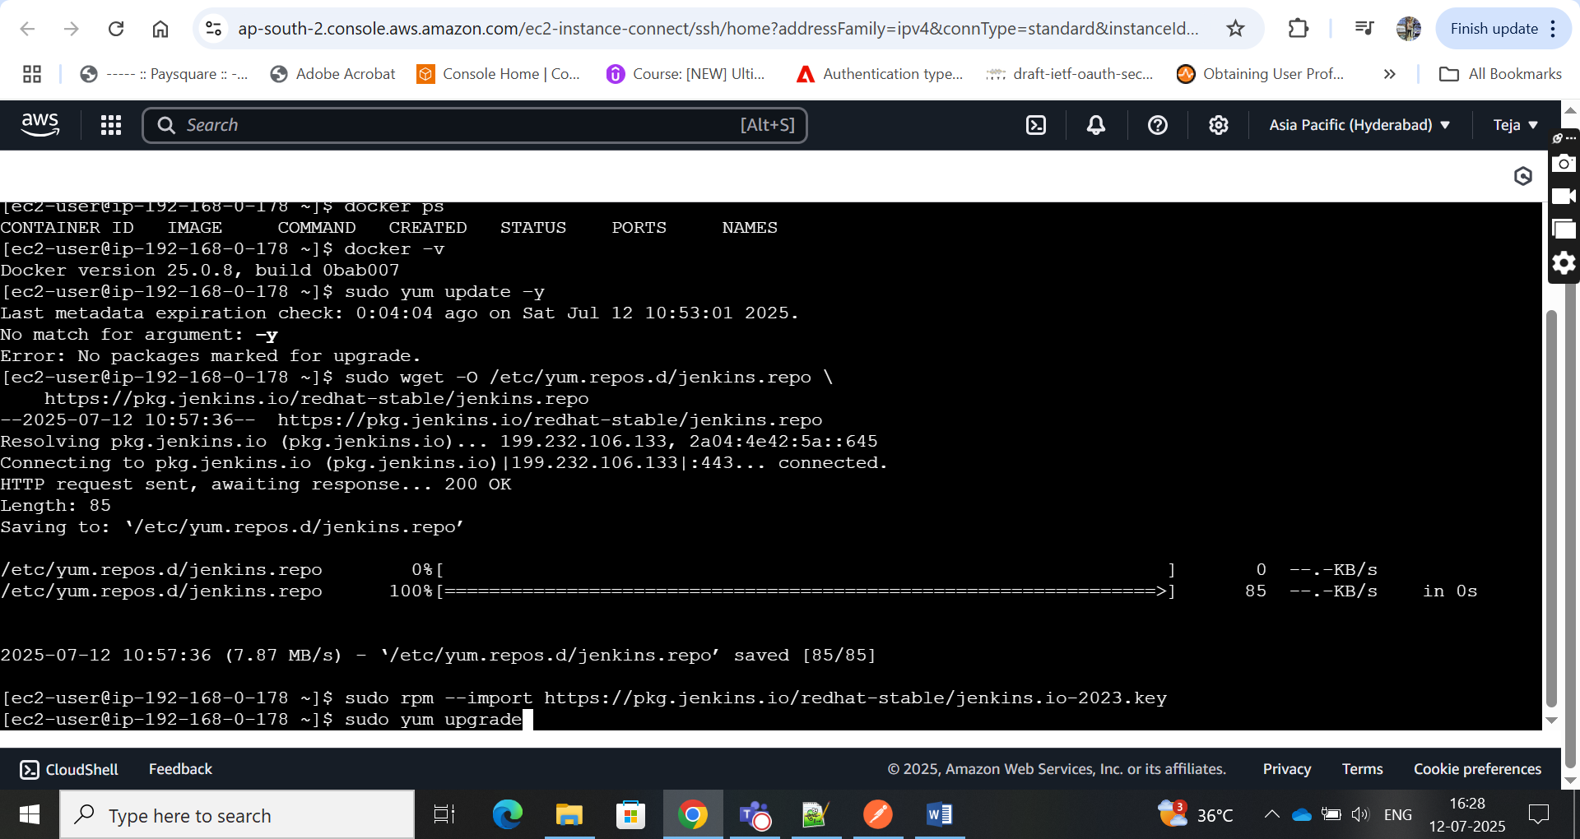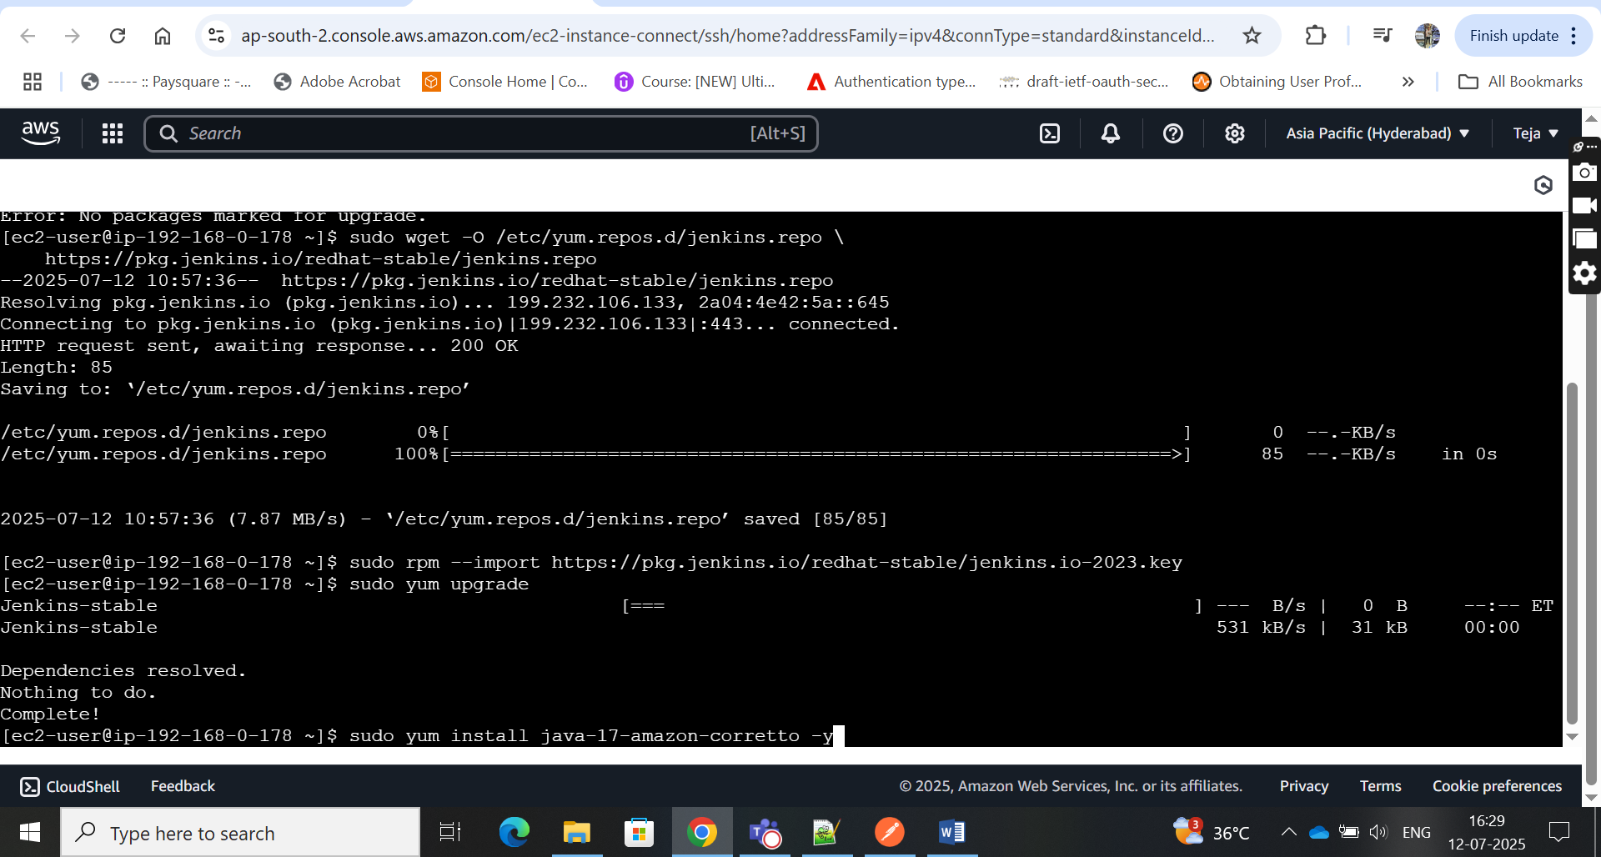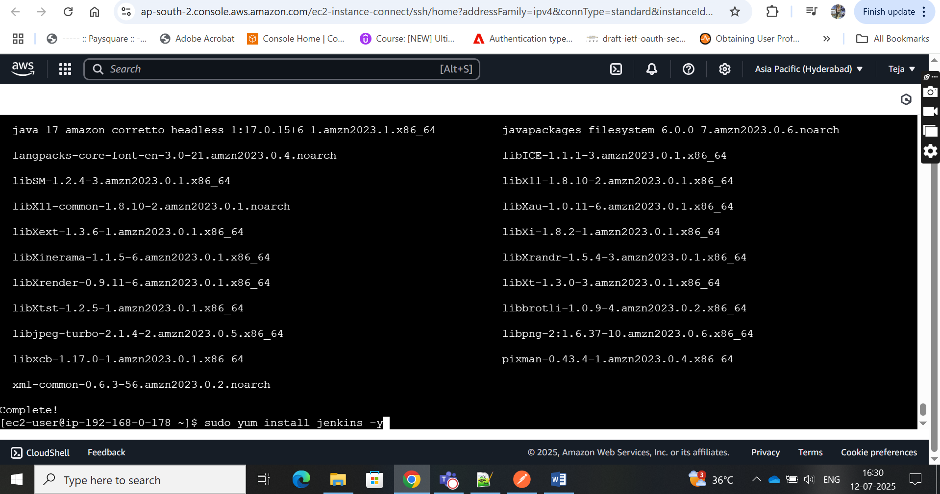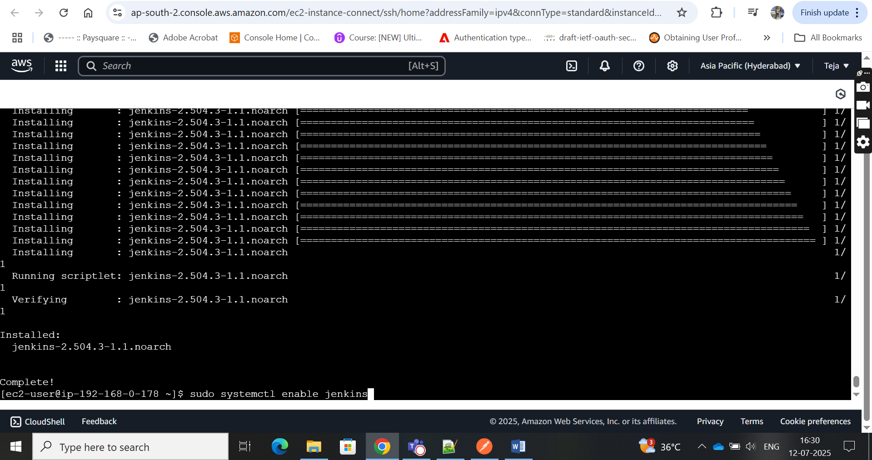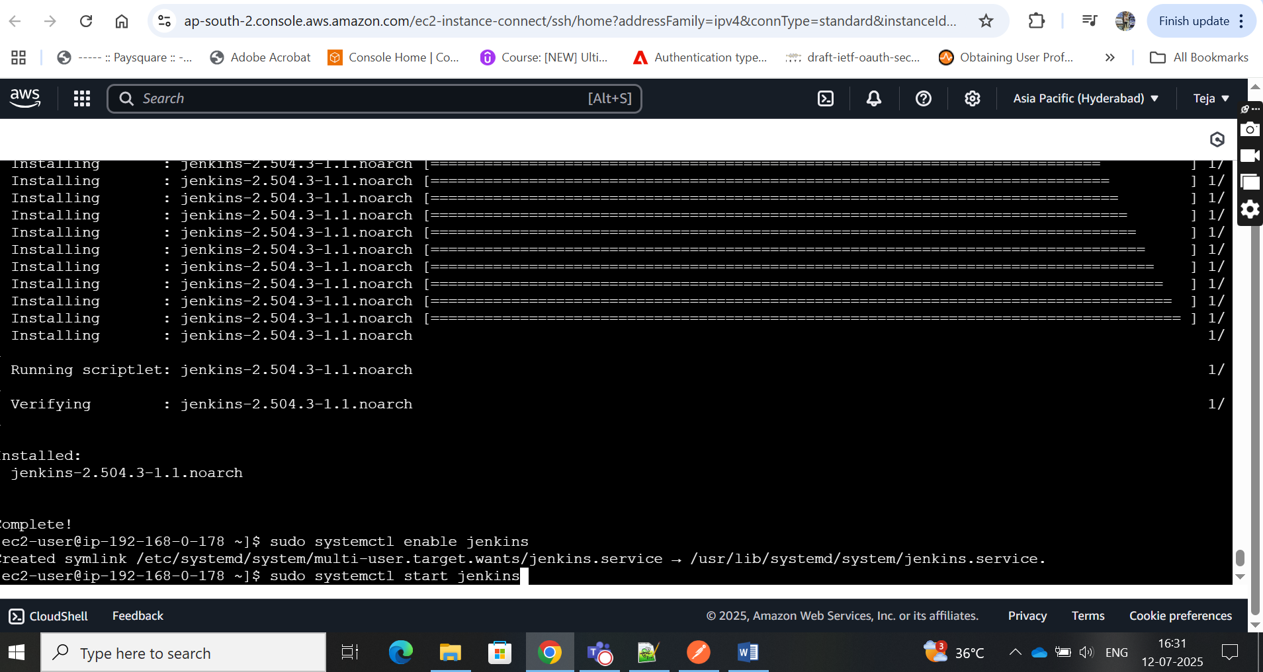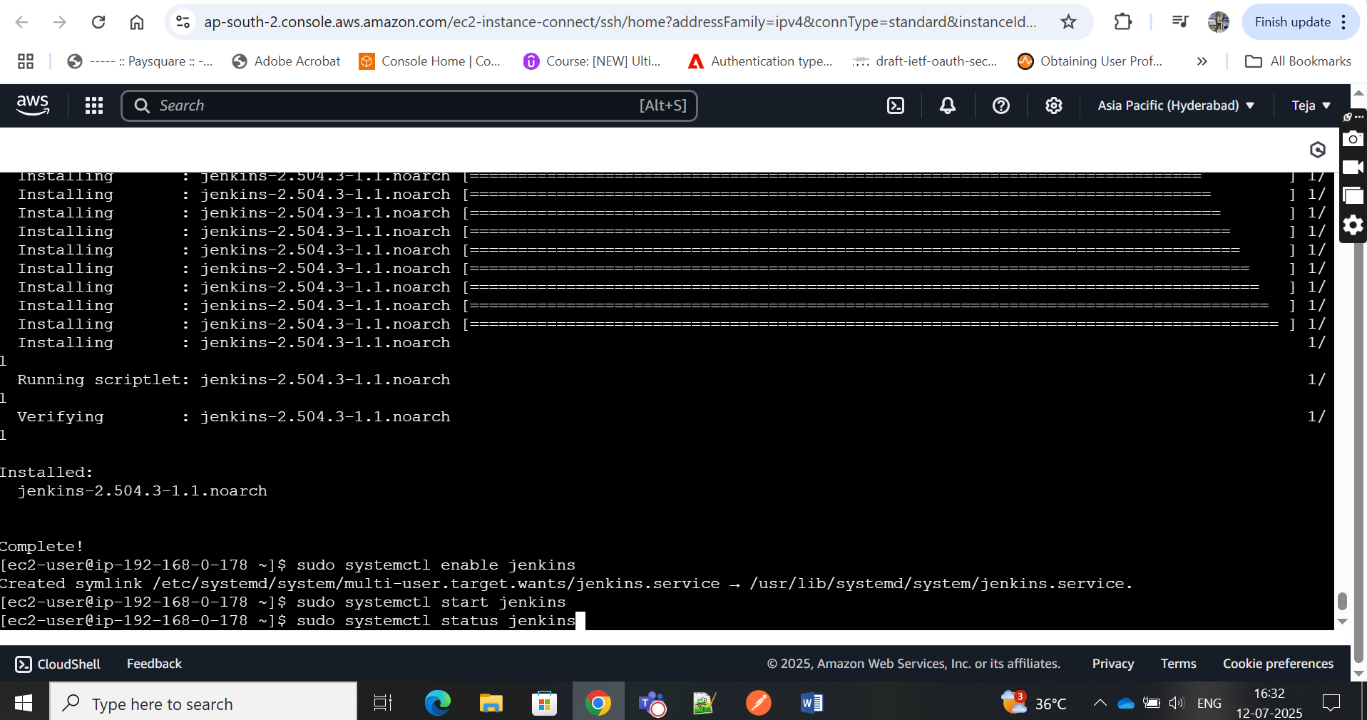

13.

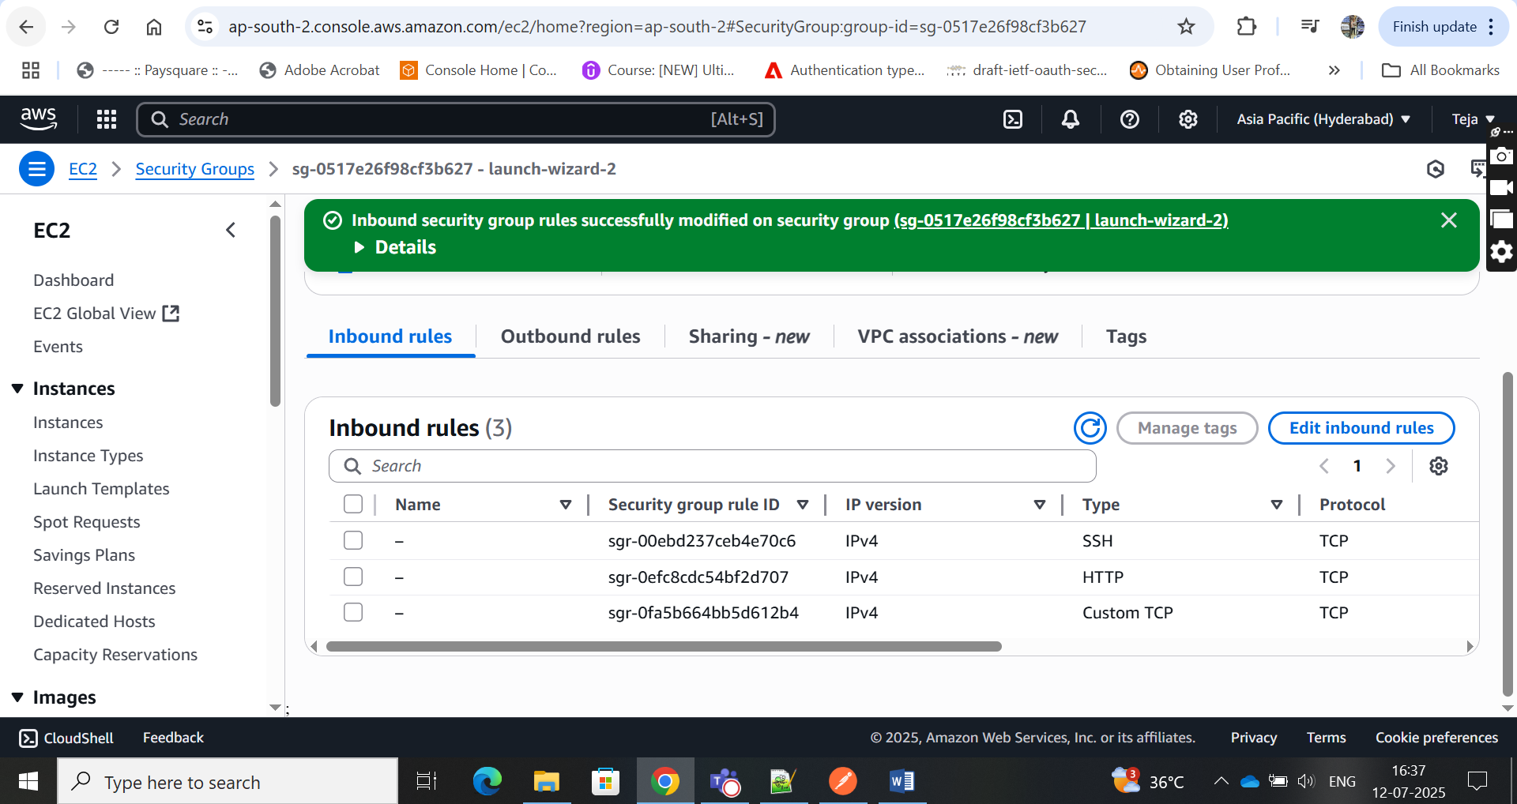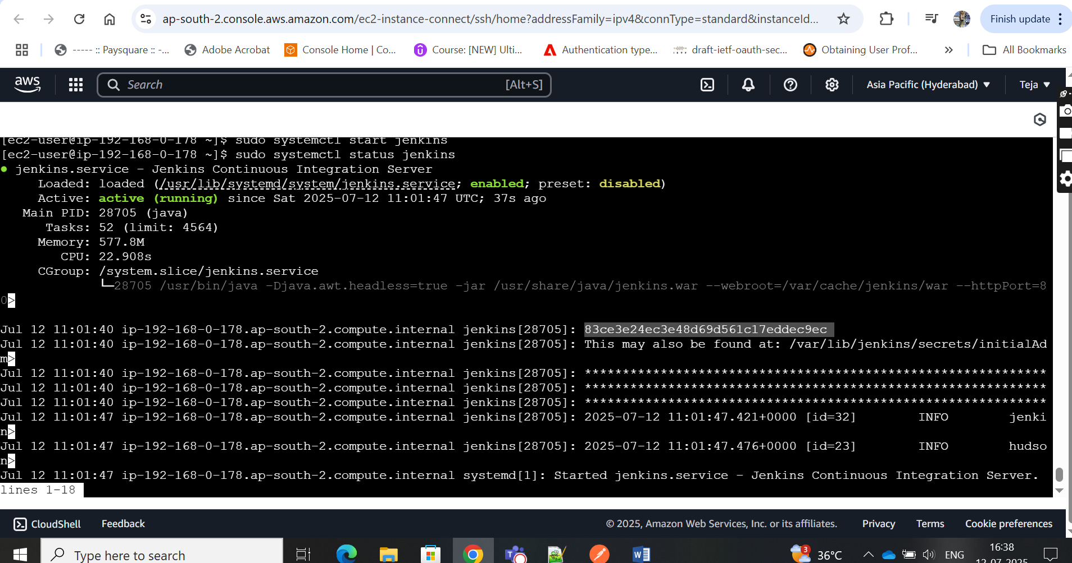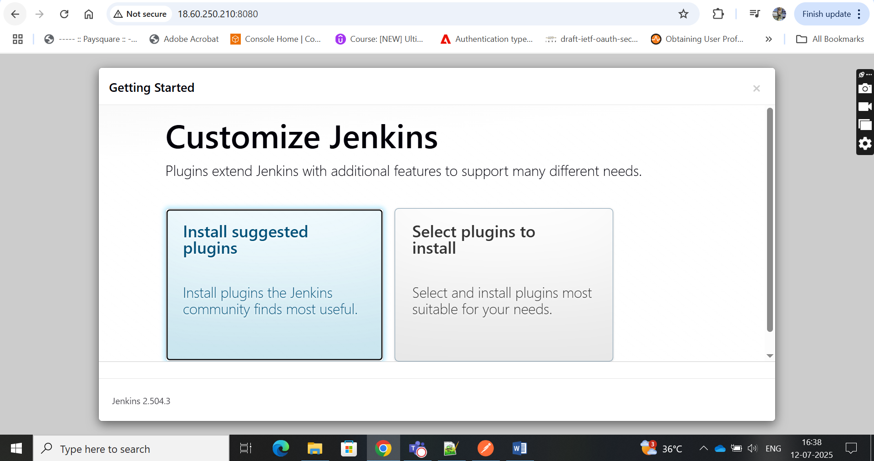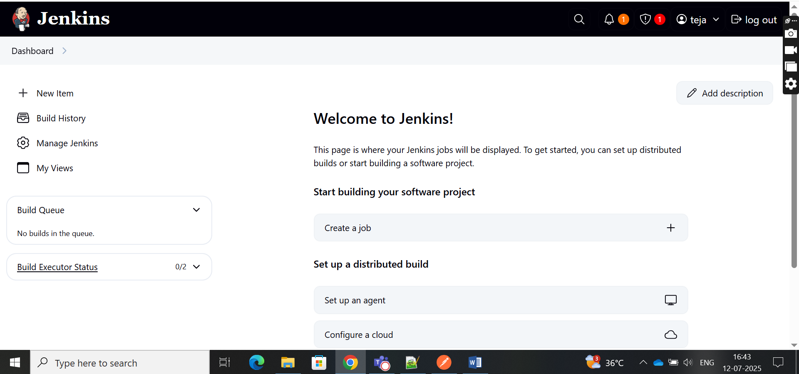

17.

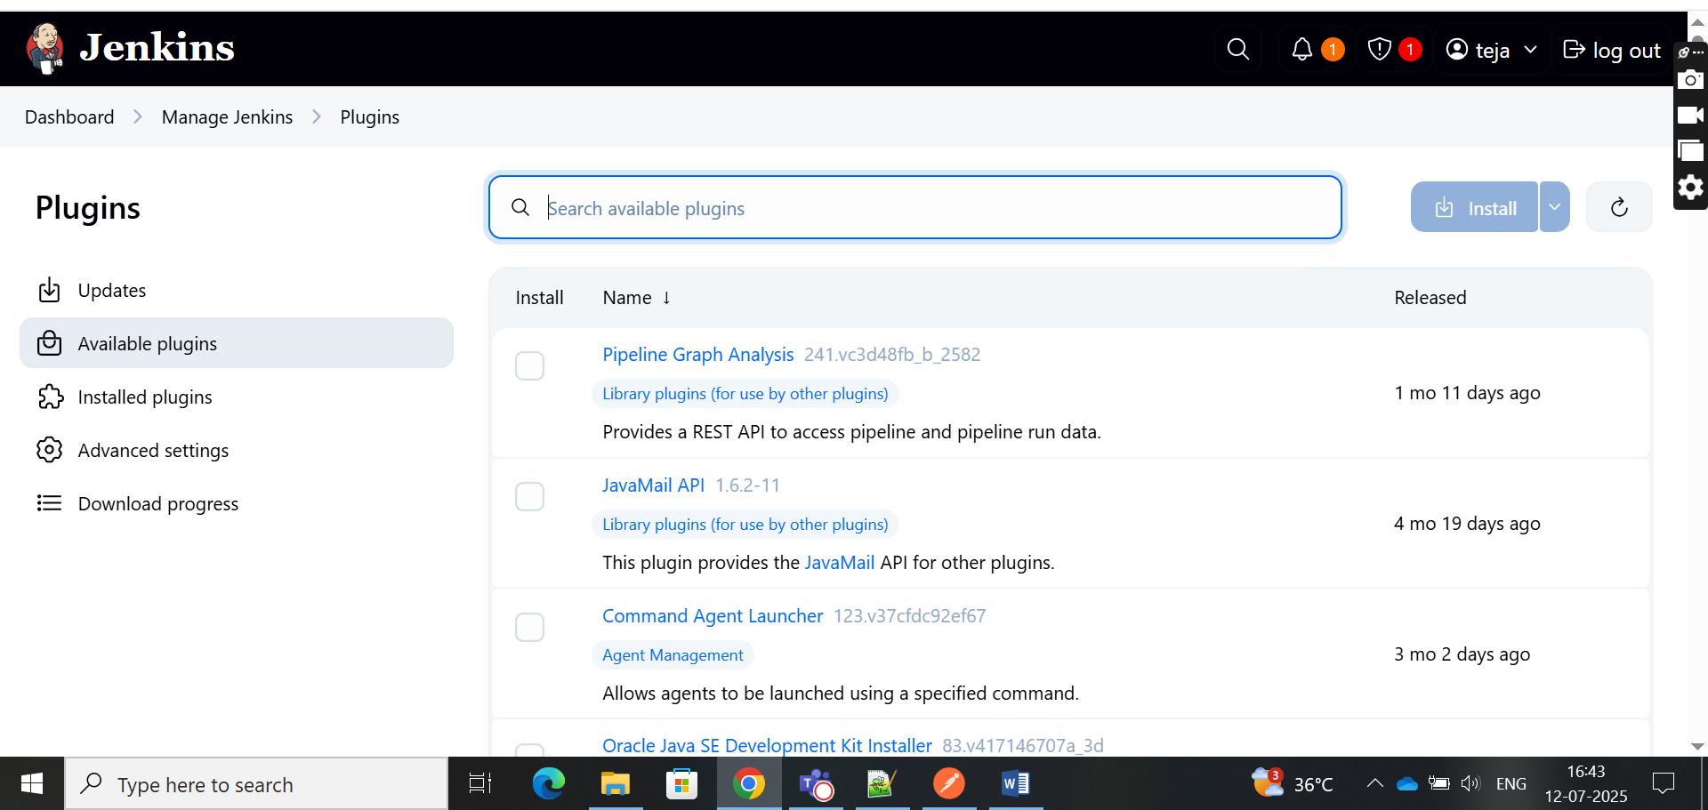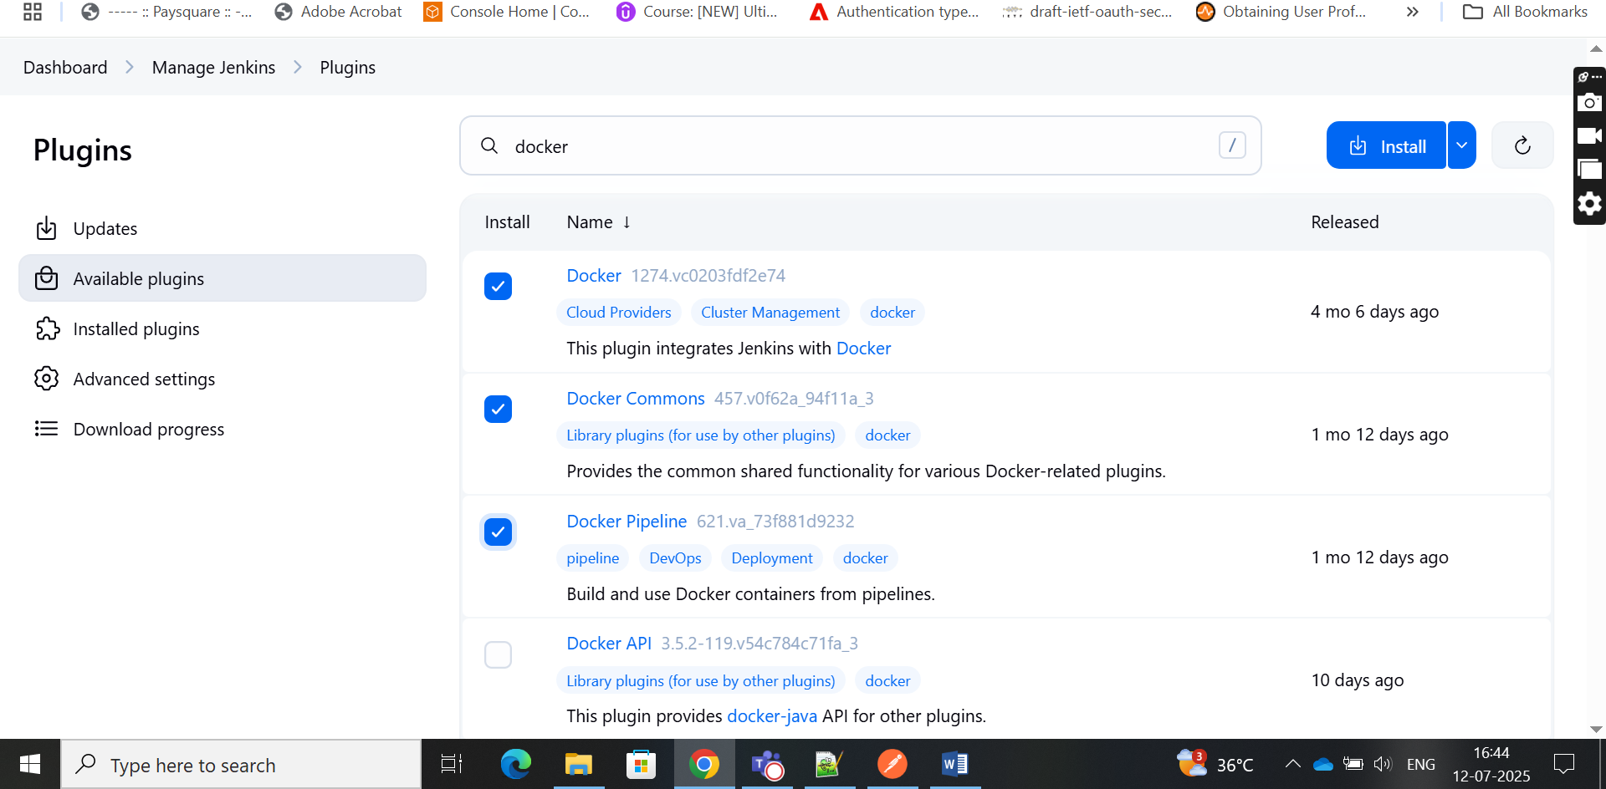

19.

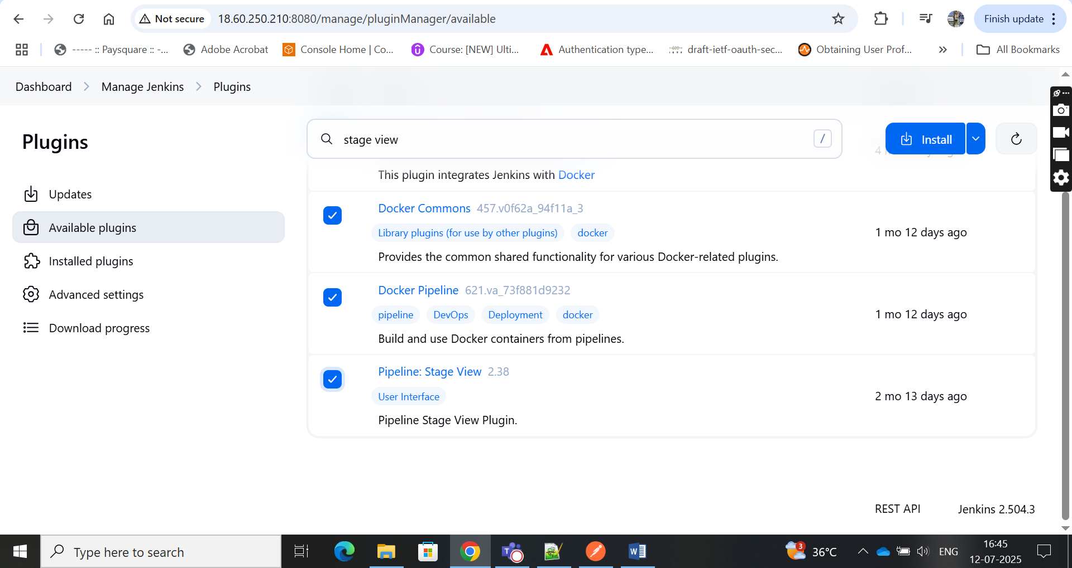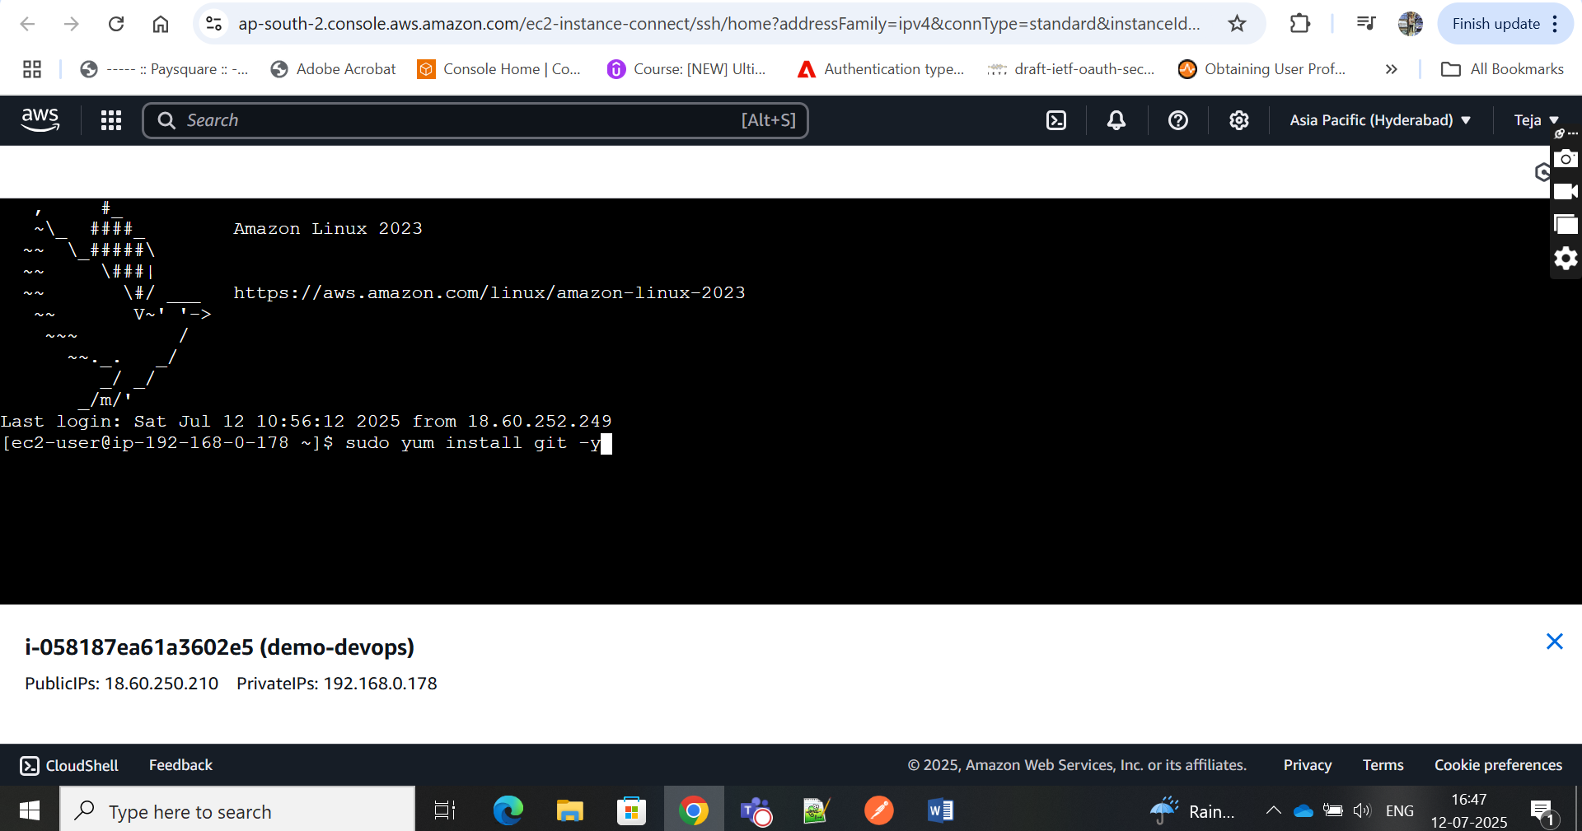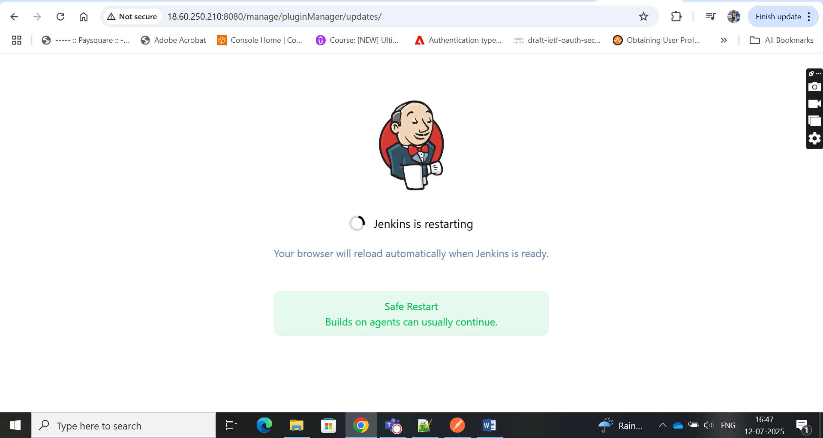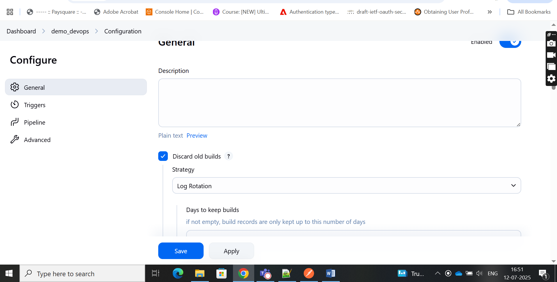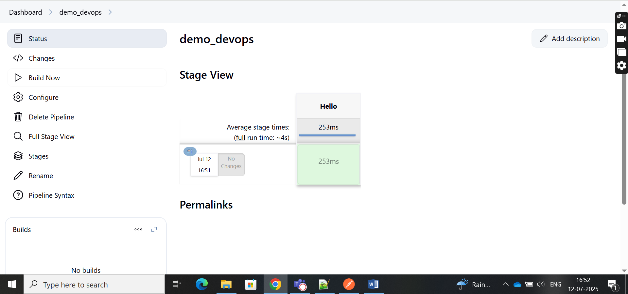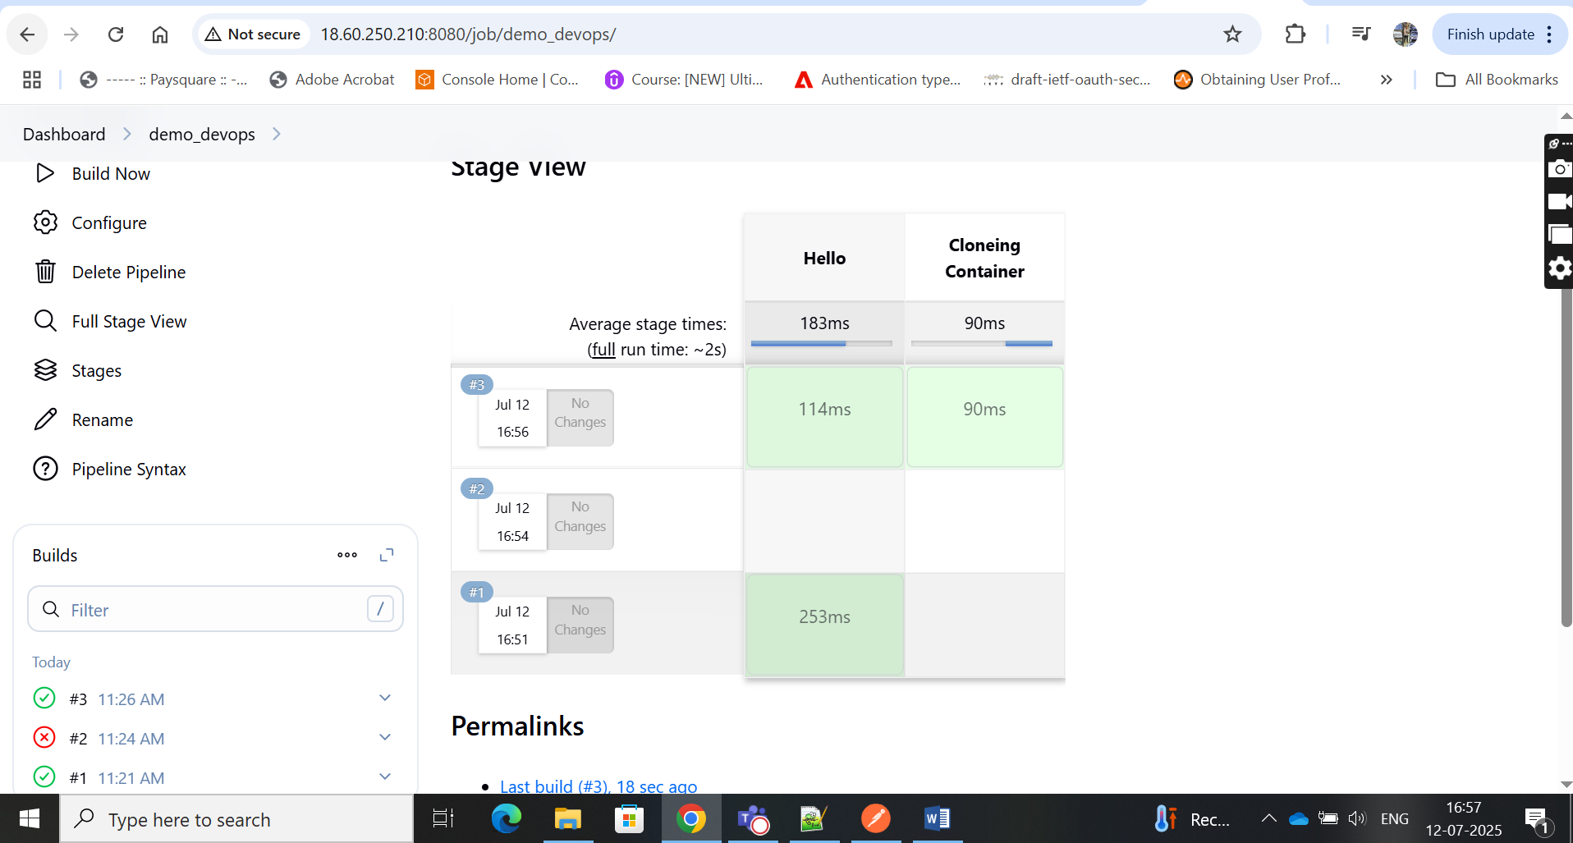

25.

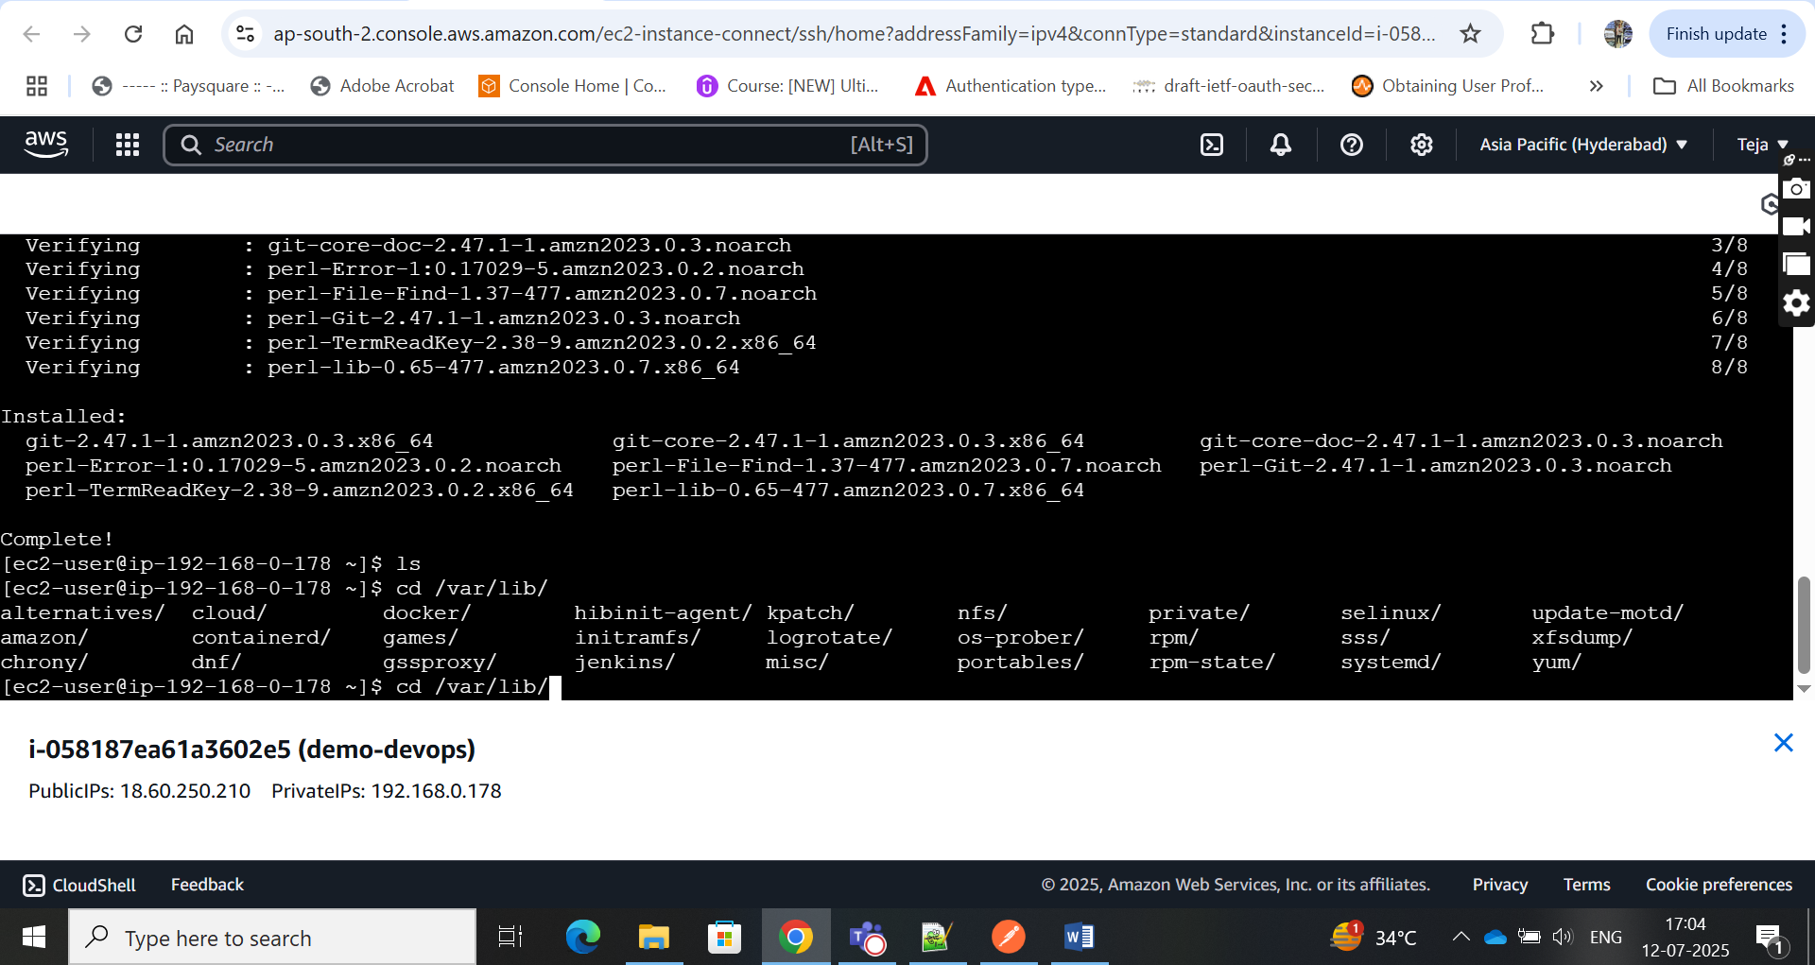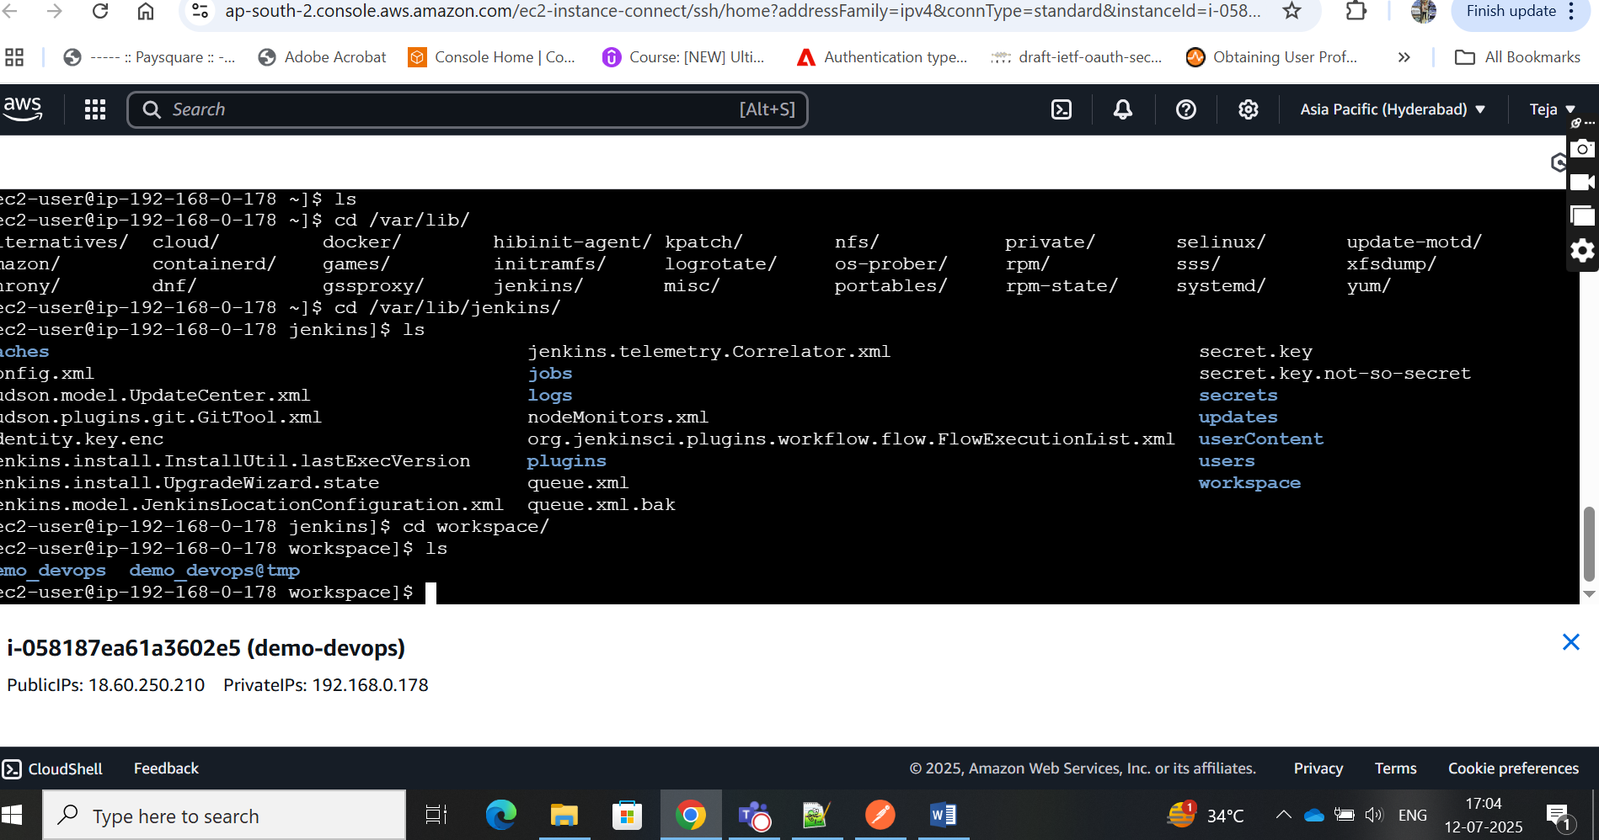

27.

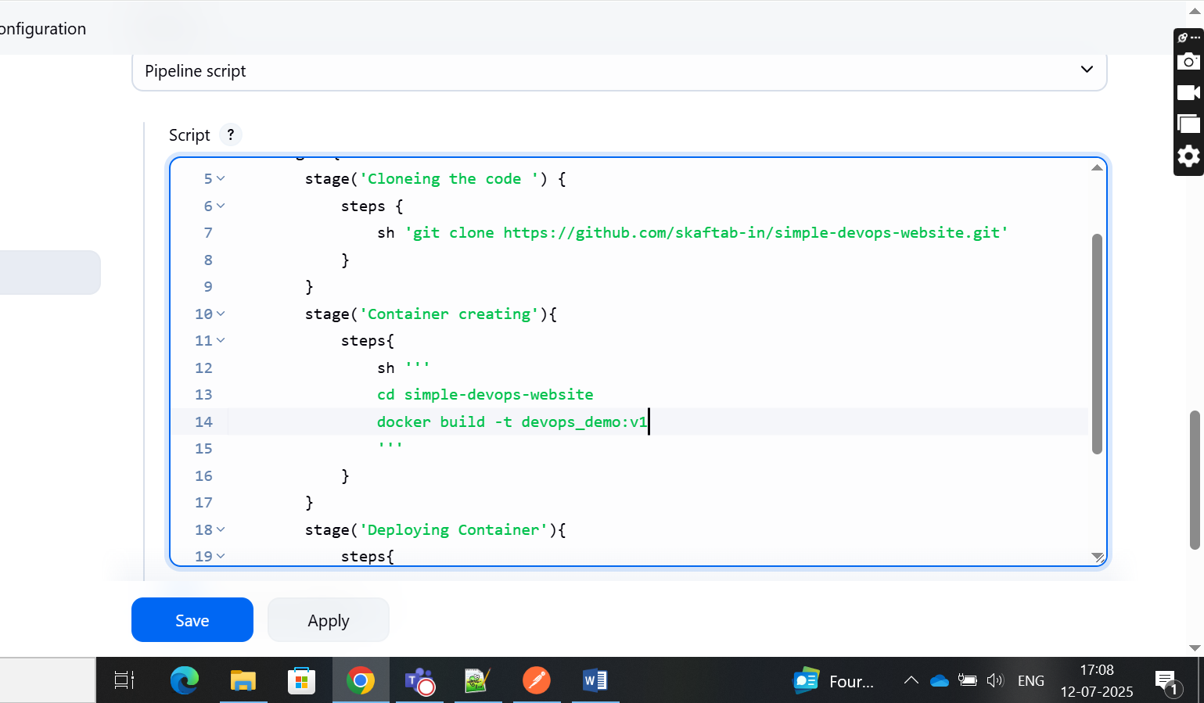

28.

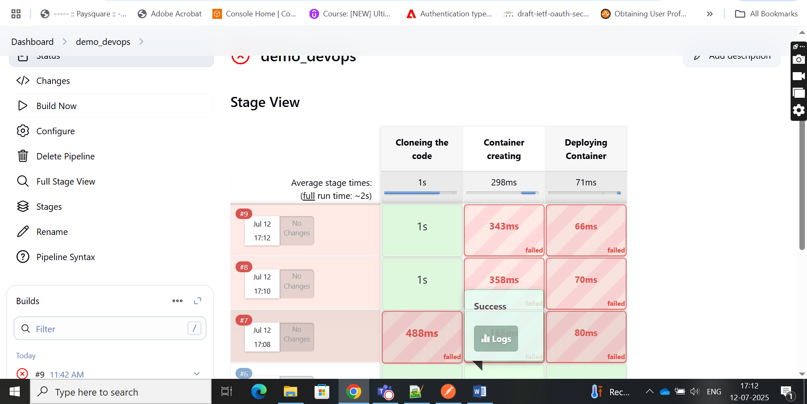

29.

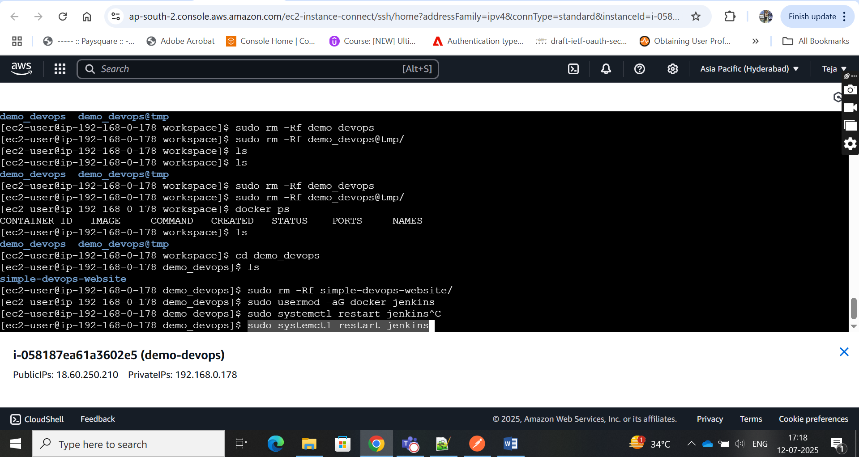

30.

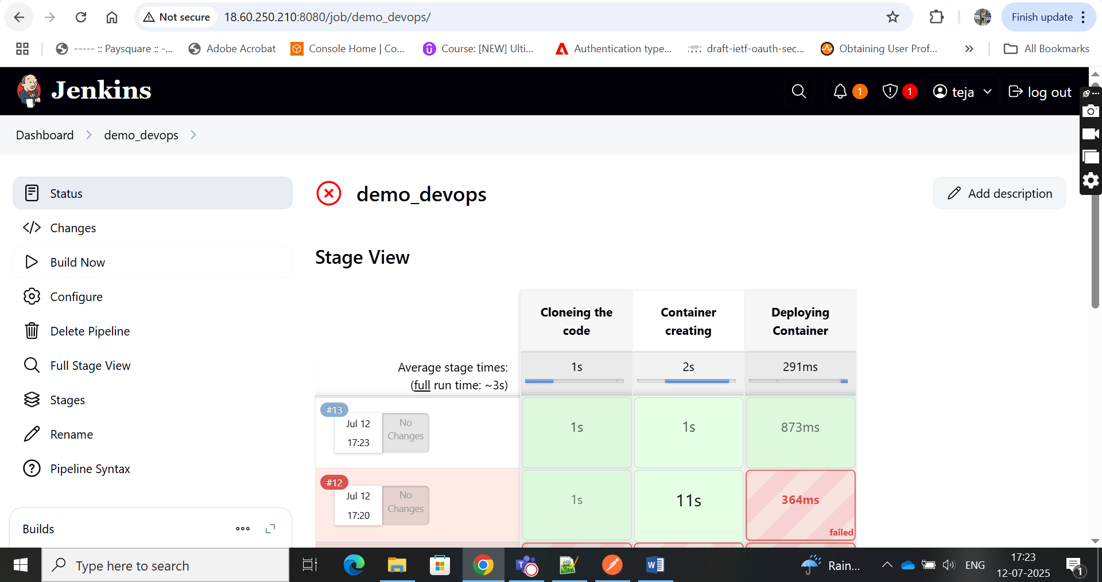

31. final

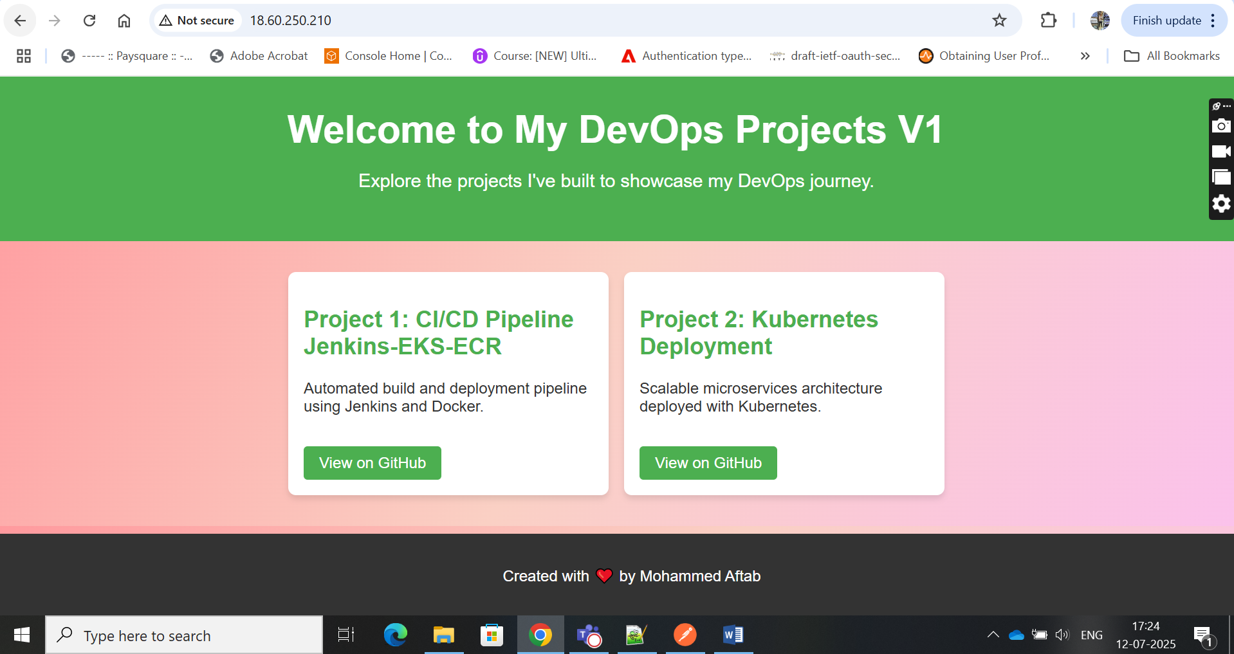

**Jenkins:**

sudo yum update –y

sudo wget -O /etc/yum.repos.d/jenkins.repo \

https://pkg.jenkins.io/redhat-stable/jenkins.repo

sudo rpm --import https://pkg.jenkins.io/redhat-stable/jenkins.io-2023.key

sudo yum upgrade

sudo yum install java-17-amazon-corretto -y

sudo yum install jenkins -y

sudo systemctl enable Jenkins

sudo systemctl start jenkins

sudo systemctl status jenkins

**Dockers:**

sudo yum update –y

sudo yum install -y docker

sudo service docker start

sudo usermod -a -G docker ec2-user

docker ps

**Git:**

sudo yum install git

/var/lib/jenkins/workspace

sudo rm -Rf simple-devops-website/

sudo usermod -aG docker jenkins

sudo systemctl restart Jenkins

last step:

docker stop (image id) command in EC2 cloud shell